Task No 01: Create a program to check whether the No is even or odd.
Input:
using System;

namespace Abdullah_Sadiq_Cp_Lab_05
{
class Program
{
static void Main(string[] args)
{
int num;
string result;
Console.WriteLine("Enter Number:");
num = Convert.ToInt32(Console.ReadLine());
Console.Write(num);

result = (num % 2 == 0) ? (" is an Even Number") : (" is an Odd Number");
Console.WriteLine(result);
}
}
}
Output:
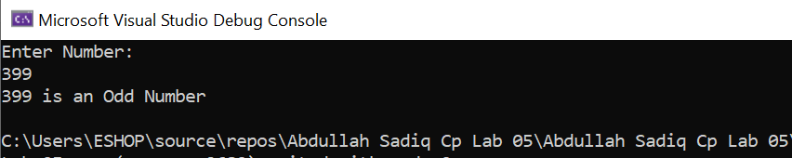
Task No 02: Create a simple calculator using if else condition in which you will take two number as input and ask user which operation he/she wants to perform.
Input:
using System;

namespace Abdullah_Sadiq_Cp_Lab_05
{
class Program
{
static void Main(string[] args)
{
char operation;
int num1, num2, result;
Console.WriteLine("Enter First Number:");
num1 = Convert.ToInt32(Console.ReadLine());
Console.WriteLine("Enter Second Number:");
num2 = Convert.ToInt32(Console.ReadLine());
Console.WriteLine("Enter Operation (+,-,*,/)");
operation = Convert.ToChar(Console.ReadLine());

switch (operation)
{
case '+':
result = num1 + num2;
Console.WriteLine("After adding {0} and {1}, result is {2}", num1,num2,result);
break;
case '-':
result = num1 - num2;
Console.WriteLine("After Substracting {0} from {1}, result is {2}", num2, num1, result);
break;
case '*':
result = num1 * num2;
Console.WriteLine("After Multiplying {0} and {1}, result is {2}", num1, num2, result);
break;
case '/':
if (num2 == 0)
{
Console.WriteLine("Math Error");
}
else
{
result = num1 / num2;
Console.WriteLine("After Dividing {0} into {1}, result is {2}", num1, num2, result);
}
break;
default:
Console.WriteLine("Invalid Operation!");
break;
}
}
}
}
Output:
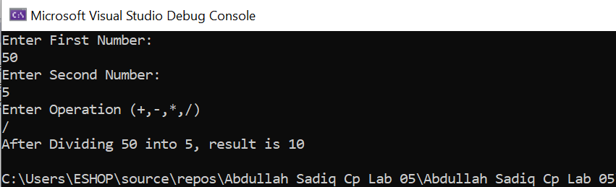
Task No 03: Write a Program using nested ifs in which the user is asked to do the following:
- Confirm if user wants to play the game “Guess the secret number”
- If false, then print message “Maybe next time”; if true, then ask “Enter your age”
- If age is less than 5 then print “You are too young to play”, else ask “Enter any number”.
- If number is equal to the secret number then print “You have successfully guessed the secret number; else print “You were not successful in guessing the secret number”.
Note: You have to store a secret number in a variable in order to compare it.
Input:
using System;

namespace Abdullah_Sadiq_Cp_Lab_05
{
class Program
{
static void Main(string[] args)
{
int secretNumber = 3123;
int secretNumberIn;
Console.WriteLine("Do you want to play a Game, Yes or No ?");
string opt = Console.ReadLine();
if (opt == "Yes" || opt == "No")
{
Console.WriteLine("Enter Your Age:");
int age = Convert.ToInt32(Console.ReadLine());
if (age > 5)
{
Console.WriteLine("Guess the Secret Number!");
secretNumberIn = Convert.ToInt32(Console.ReadLine());
if (secretNumber == secretNumberIn)
{
Console.WriteLine("Congratulations! You have successfully guessed the secret number");
}
else
{
Console.WriteLine("Sorry, You were not successful in guessing the secret Number");
}
}
else
{
Console.WriteLine("Too Young to Play!");
}
}
else
{
Console.WriteLine("Ok sure, Have a Nice Day");
}
}
}
}
Output:

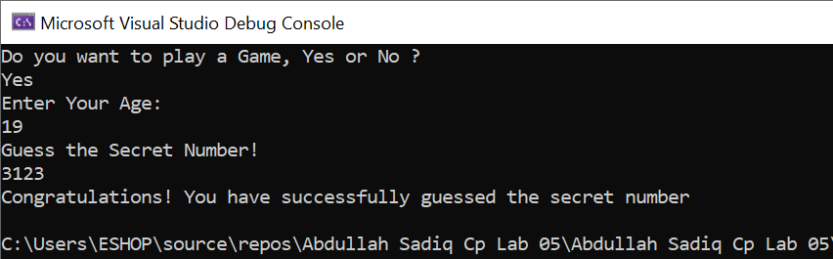

Task No 04: Create a simple application which will check the vowel using switch case.
Input:
using System;

namespace Abdullah_Sadiq_Cp_Lab_05
{
class Program
{
static void Main(string[] args)
{
string v;
Console.WriteLine("Enter an Alphabet:");
v = Console.ReadLine();
switch (v)
{
case "a":
Console.WriteLine("{0} is a Vovel.",v);
break;
case "e":
Console.WriteLine("{0} is a Vovel.", v);
break;
case "i":
Console.WriteLine("{0} is a Vovel.", v);
break;
case "o":
Console.WriteLine("{0} is a Vovel.", v);
break;
case "u":
Console.WriteLine("{0} is a Vovel.", v);
break;
default:
Console.WriteLine("{0} is a Consonant.", v);
break;
}
}
}
}
Output:
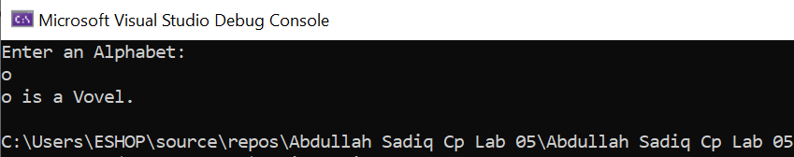

Task No 05: Create a simple program for Bahria Check in system.
Input:
using System;

namespace Abdullah_Sadiq_Cp_Lab_05
{
class Program
{
static void Main(string[] args)
{
string campus = "BUKC";
string campusIn;

Console.WriteLine("\t-Student Data Check for Entry-");
Console.WriteLine("-Are you from Bahria University?");
Console.WriteLine("\tPress Y for Yes, N for No");
string opt = Console.ReadLine();
if (opt == "Y")
{
Console.WriteLine("-From which Campus?");
campusIn = Console.ReadLine();

if (campus == campusIn)
{
Console.WriteLine("You are allow to Enter, have a Nice Day");
}
else
{
Console.WriteLine("Sorry you are not allow to Enter BUKC");
}
}
else
{
Console.WriteLine("Sorry You are not allow to enter Bahria University");
}
}
}
}
Output:
